
ST ANDREW’S JUNIOR COLLEGE
Preliminary Examinations
Higher 2

Geography 9173/02
Paper 2 15 September 2026
INSERT 3 hours

READ THESE INSTRUCTIONS FIRST

This insert contains all the Resources referred to in the questions.

This document consists of 8 printed pages and 1 blank page.

[Turn over
Resource 1 for Question 1

Location and selected characteristics of the three fieldwork sites in Bangkok

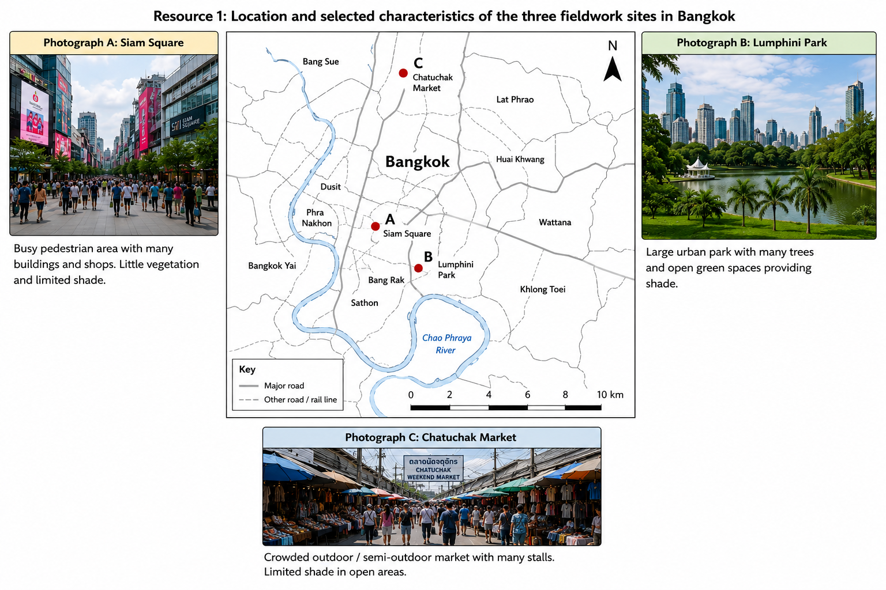

Resource 2 for Question 1

Questionnaire used by the students

Questionnaire no.: | ____________ | Site: | A / B / C

Please tick one response for each question, unless the question states otherwise.

1 What is your age group?
□ Under 18 | □ 18–29 | □ 30–44 | □ 45–59 | □ 60 or above

2 How serious a risk do you think heatwaves pose to you?
□ | □ | □ | □ | □
1  Very low | 2 | 3 | 4 | 5  Very high

3 How much do heatwaves disrupt your normal daily activities?
□ | □ | □ | □ | □
1  Not at all | 2 | 3 | 4 | 5  Very greatly

4 During heatwaves, how often do you change the timing or location of your usual outdoor activities?
□ Never | □ Rarely | □ Sometimes | □ Often | □ Always

5 Which measures do you usually take during heatwaves? Tick all that apply.
□ Drink more water / carry water | □ Seek shade when outdoors
□ Stay indoors or use air-conditioning / fans | □ Change the timing of outdoor activities or travel
□ Wear light clothing / use a hat or umbrella | □ Other: __________________________

6 Which group do you think is most vulnerable to heatwaves?
□ Children | □ Elderly people | □ Outdoor workers
□ People with existing health conditions | □ Everyone is equally vulnerable | □ Other: __________________

Thank you for your time.

The same questionnaire was used at all three fieldwork sites.

Resource 3 for Question 1

Results of the questionnaire survey

Thirty people were surveyed at each fieldwork site (90 respondents in total).
Site | Under 20 | 20–39 | 40–59 | 60 and above | Mean perceived heatwave-risk score (1–5) | Mean disruption to daily activities (1–5) | Often/always changed outdoor activities (%) | Mean number of heat-reduction measures used
A  Siam Square | 9 | 14 | 5 | 2 | 4.2 | 3.8 | 67 | 3.2
B  Lumphini Park | 5 | 8 | 10 | 7 | 3.5 | 3.1 | 47 | 2.5
C  Chatuchak Market | 4 | 13 | 8 | 5 | 4.4 | 4.0 | 73 | 3.5

Relationship between perceived heatwave risk and heat-reduction measures
Perceived heatwave-risk score | Number of respondents | Mean number of heat-reduction measures used | Respondents who often/always changed outdoor activities (%)
1–2 | 10 | 1.6 | 20
3 | 20 | 2.3 | 35
4 | 34 | 3.1 | 62
5 | 26 | 3.8 | 81

Most commonly reported heat-reduction measures
Heat-reduction measure | Respondents selecting measure (%)
Drink more water | 82
Seek shade | 69
Stay indoors or use air-conditioning | 61
Change travel or activity time | 44
Reduce outdoor activity | 38

Note: Risk and disruption scores use the 1–5 scales in Resource 2. Respondents could select more than one heat-reduction measure, so percentages in the final table do not total 100%.

[Turn over

Resource 4 for Question 2

Urban population living in slums between 2000 and 2018

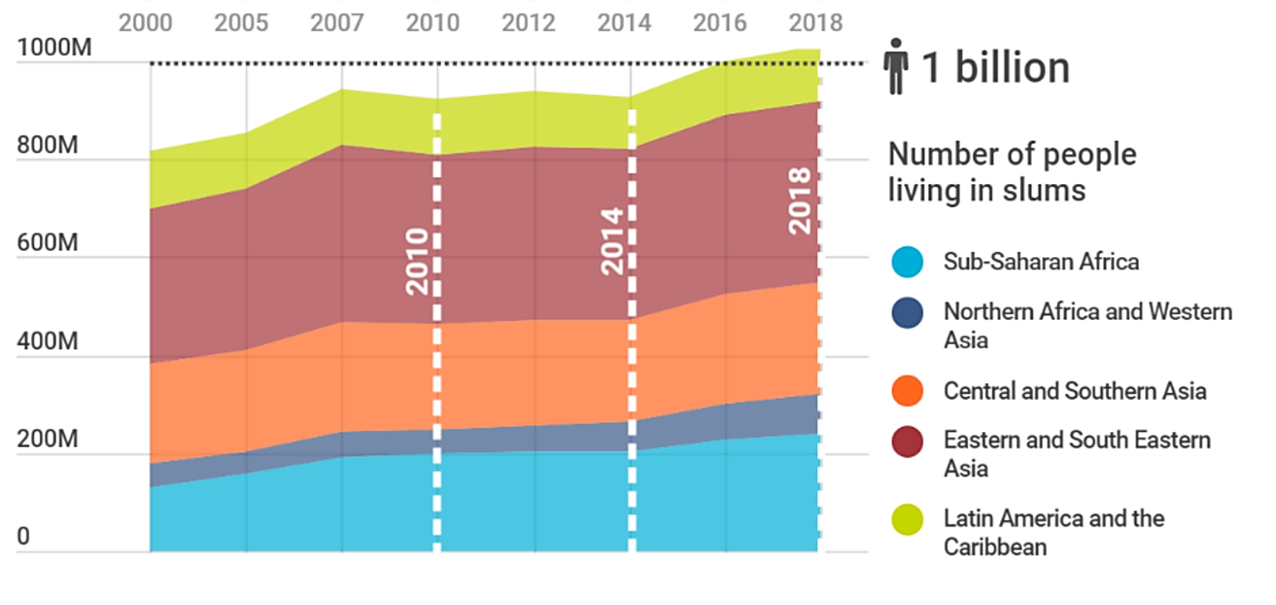

Resource 5 for Question 2

Photograph showing a slum settlement before and after an upgrading project

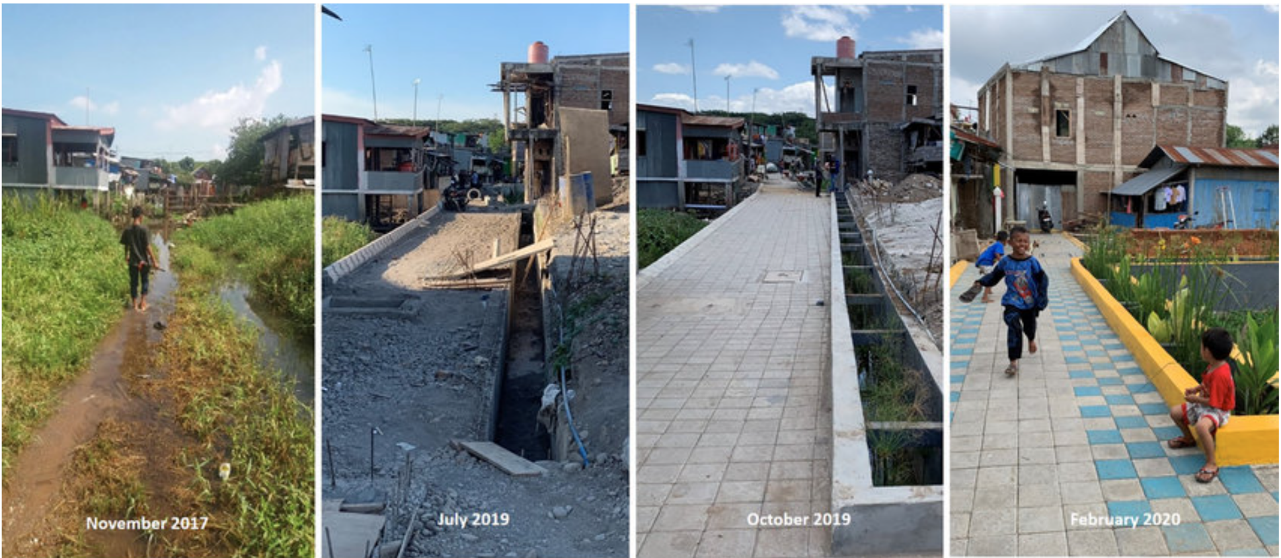

[Turn over
Resource 6 for Question 2

Extent of summer ice cover in the Northern Hemisphere,
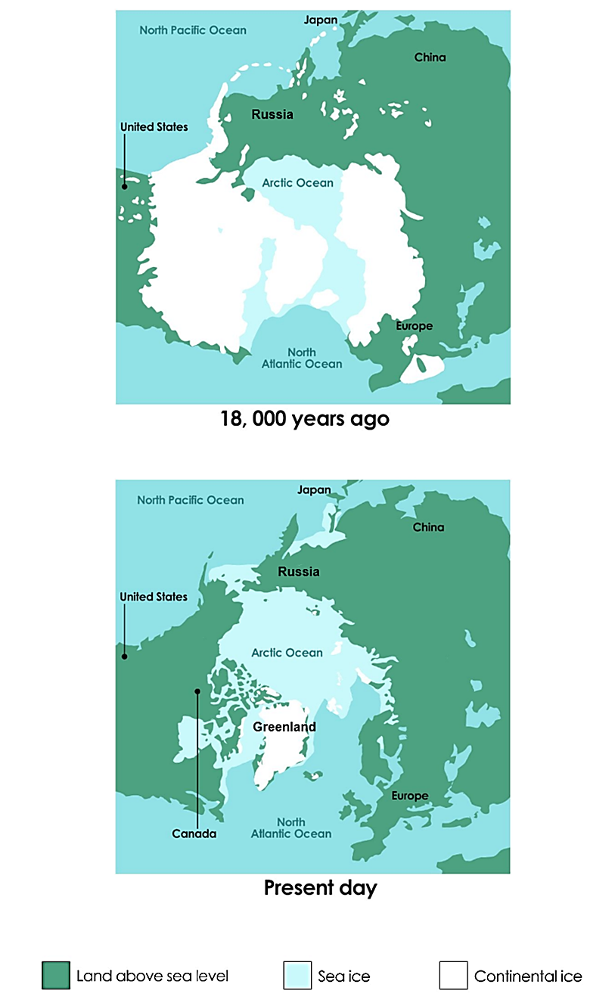
18,000 years ago and Present Day
Resource 7 for Question 2

Influence of high and low clouds on heat energy trapped in the atmosphere
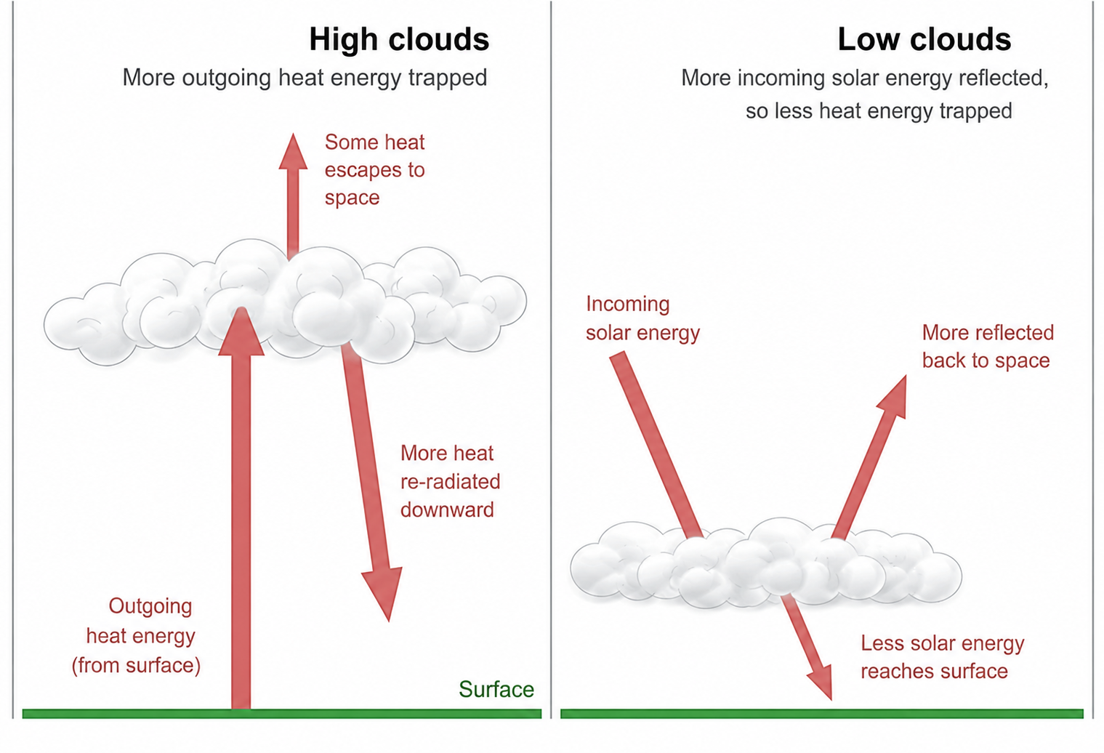

BLANK PAGE

